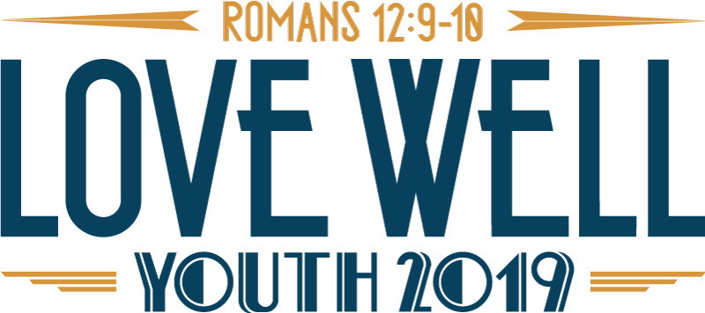

Code of Conduct:
As a representative of Christ and of the United Methodist Church, we, the participants of YOUTH 2019, take seriously our responsibility to care for one another. This code represents affirmation of our concern for the well-being of the total community. We covenant with each other to insure the safety of all, to make our time together most meaningful, and to care for the facility which we share.
- Anything considered illegal under civil and criminal law in Tennessee is illegal for participants of YOUTH 2019. This includes drug possession and use, alcohol consumption and possession by a minor (anyone under 21) and alcohol consumption on state property, possession of firearms, weapons, or fireworks, etc. Tobacco use is illegal for those under 18. Smoking is discouraged for adults but will be permitted in outdoor areas.
- All groups must adhere to Safe Sanctuary policies in addition to the 5:1 youth to adult ratio, all groups with both male and female participants must bring at least one leader/chaperone (age 21+) of each gender. Each group is encouraged to have a least one leader/chaperone that is 25 years old or older.
- Dress should be appropriate for a co-ed Christian environment.
- All participants are expected to participate in the event in full and be at designated places at all times.
- Visitation between males and females in hotel rooms is prohibited unless directly supervised in a group setting by the group’s responsible adult.
- We will respect the person, equipment and property of others as well as the public and private properties (hotel and conference rooms, etc.) we will be using during YOUTH 2019. (This should be taken into consideration when considering practical jokes, water fights, use of shaving cream, etc. Do no harm to others.)
- Any accidental damage to the hotel or convention area property will be billed to the local church and will be the responsibility of the persons who caused the damage. Intentional damage is subject to additional penalties.
I understand that violations of this covenant and/or other inappropriate behavior could require disciplinary action for youth and adults. Decisions about appropriate disciplinary action will be made by group leaders and the YOUTH 2019 Design Team. YOUTH 2019 reserves the right to call parents or to dismiss any person who breaks this code of conduct.

Participant Signature & date _______________________________________________________________________
Parent/Guardian Signature (if under 18) & date _________________________________________________

